Positive Behaviour Support Policy

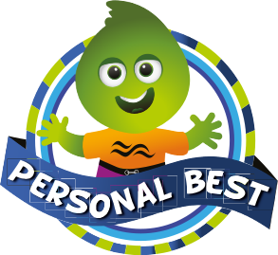
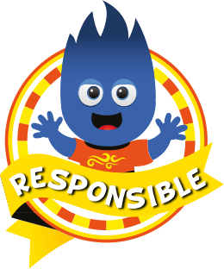

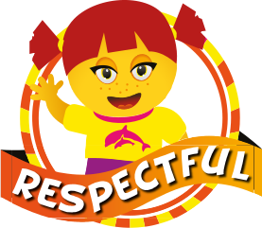

Policy & Guidelines

Mission Statement - Our purpose to develop and implement School Wide Positive Behaviour Support in order to improve behaviour, teach social skills and foster a positive attitude towards learning to achieve higher educational outcomes. It is our intention that this will develop a school culture which is consistent and based on a common language which is used by all and caters of the diversity of the school population.

- Behaviour is learned, therefore responsible behaviour can be taught.
- Student discipline is best achieved through instruction rather than punishment.
- Student behaviour can be taught using the same strategies used to teach academics.
- Misbehaviour presents the student with an opportunity to learn, the educator with an opportunity to teach.
- Punishment focuses on what not to do and does not teach the student alternative successful ways to behave.

- For behaviour change to occur, we must use positive approaches that strengthen teacher-student relationships.
- Efforts to help students become socially competent require ongoing teaching, encouragement and correction.
- Students need and want high standards for their behaviour. Maintaining high expectations does not require “get tough” or punitive approaches.
- Successful change in discipline practices requires school wide, systematic approaches.
- Student discipline is a shared responsibility and requires a combined effort by all staff.
- Student discipline is a collaborative effort. All staff must work together, developing consensus on procedures and consistent implementation.
- Services for students with chronic or intense behaviours are most effective within the context of a larger school wide commitment to the social development of all students.

Effective Leadership

The Dalyellup Primary School PBS Leadership Team is a representative group of school stakeholders who meet regularly to develop PBS at Dalyellup Primary School. The PBS Leadership Team will lead the school staff in the continual process of developing and maintaining a positive school environment where there are high expectations for student behavioural and academic achievement. This team will thoughtfully involve the entire staff in rethinking their beliefs about student behaviour, reviewing existing procedures, and developing more effective policies and practices individualised to their school context.

Defining Expected Behaviour

# We explicitly teach our expectations to the students as outlined in our “Behaviour Matrix “and encourage and acknowledge them frequently for displaying the expected behaviour.

# The expectations for all students are clear throughout the school.

# Our expectations provide for a safer school environment and give more time for instruction.

# By detailing expected behaviours and teaching these to students in a positive way, we provide a common language for everyone at Dalyellup Primary School.

Teaching Expected Behaviour

# We cannot assume that students know how to behave appropriately when at school.

# Success in a school environment requires students to learn a new set of skills specific to the classroom and playground environment.
# Research has shown that the implementation of punishment, especially when it is used inconsistently and in the absence of other positive strategies, is ineffective.

# Plan to teach the expectations over the first 2-3 weeks of school. Lessons will need to be repeated and reviewed throughout the year.

# Keep lessons brief (5-15 minutes typically). Providing frequent, brief lessons is more effective than providing a few long lessons.

Encouraging Expected Behaviour

Encouraging expected behaviour is crucial to help students learn the desired expectations and to shift the focus from addressing behaviour to responding with positive feedback to expected social behaviour.
All staff help set the tone or mood of the school through relationships with students and families, and frequently recognising students’ efforts to meet academic and behavioural goals.

# Clear and Specific: Simply describe the skill observed to make the feedback clear and specific. Do not add any references to past mistakes the student has made or wishes for future behaviour.

# Sincerely and Appropriate for Student’s Age: A genuine response to the desired behaviour that is appropriate for the situation and the individual.

# Private: Know your students well enough to differentiate how you give feedback to students. Some students will like to be publicly recognised while other students will not find public encouragement reinforcing at all.

# Genuine: Staff need to find their own style to communicate sincere encouragement. This is especially important when working with older students.

PBS Essential Classroom Practice

Key guidelines

- Belonging and Student Engagement
- Classroom Acknowledgment & Encouragement of Expected Behaviour
- Active Supervision
- Multiple Opportunities to Respond
- Developing Explicit Classroom Procedures and Routines
- Providing Academic Choice

Responding to Unproductive Behaviour

Good Standing

The department requires schools to implement a Good Standing Policy.
At Dalyellup Primary School, all students commence each term in possession of good standing status.
During the course of the term, students may lose good standing for any act deemed sufficiently serious or as a result of an accumulation of minor behaviours. This determination will be made by Administration.
Loss of good standing may result in a student being denied access to extra curricula activities conducted by the school e.g. Discos, interschool sporting events, etc.

Structured Play

In an attempt to more positively deal with Tier 2 behaviours and stay faithful to the PBS philosophy of teaching, rather than punishment, our PBS committee has developed a Time-In system.
It is a purpose-resourced program that will run:

1. Time-In

Time-In will replace “detention” and punitive systems with a PBS approach.
The students with Staff will go through a range of reflection, check-in and positive goal setting strategies with students that are referred to Time-In for poor behaviour in or out of the classroom.
The program will be equipped with a range of resources to help facilitate improved behaviour outcomes. These include reflection worksheets, artistic responses to behaviour management, social games that are used to model positive interactions.

1. Teacher Managed Minor Behaviour

Dalyellup Primary School Positive Behaviour Support Referral Process
2. Low Level Response
Prompt / Re-Direct / Re-Teach
Provide Choice / Conference

Consequences

3A.Classroom
Isolation in class
Minor Behaviour Reflection

3B.Playground

Walk with teacher

4. Behaviour Stops
Give positive verbal/social acknowledgement
5A. Classroom Behaviour Continues
Buddy class – reflection activity
Repeat – Minor Behaviour Reflection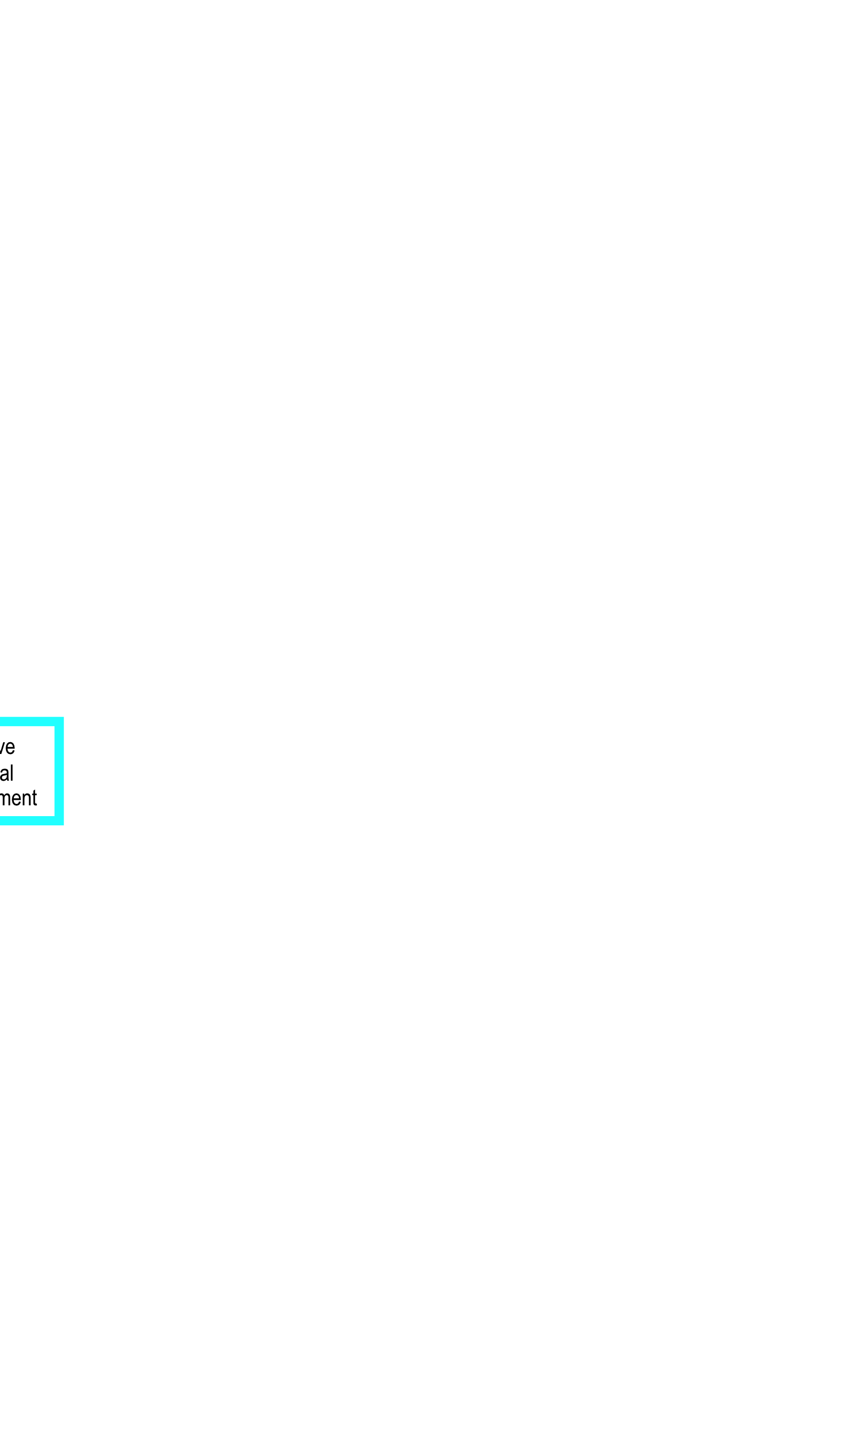Minor Behaviour Record
5B. Playground Behaviour Continues
Office Referral (Blue Slip)

Minor Negative Behaviours

Repeated answering back
Disruption
Inappropriate comments
Lateness
Minor Physical contact
Not following instructions
Out of area
Minor property misuse
Technology misuse
Unprepared
Work avoidance

1. Administration Managed Major Behaviour

2. Teacher Response
Inform student of rule violation
Complete Office Referral Form
Student to Administration

3. Administration Actions
Review Incident
Determine Consequences Time In / Withdrawal / Suspend
Enter Data

4. Administrator -
Informs Guardian
Provides Teacher Feedback

5. Third Office Referral
Parent Interview
Complete referral for Tier 2 team intervention

Major Negative Behaviours

Verbal abuse
Intimidation
Physical assault
Bullying
Defiance / refusal
Leaving school grounds
Property misuse / damage
Repeated Minors (3-5 per week)

Break Time Procedures

A variety of teachers interact with students in the Break Times over the week. Therefore, it is important that all staff are as consistent as possible in implementing the playground procedures.

General
- No hat no play in the sun. Students with no hat must sit in a covered area.
- A group of nominated primary students will, at the end of lunch, monitor the return of sports equipment.

Eating Areas
- The first 15 minutes of lunchtime is a play period and will finish when the siren is sounded.
- During 2nd Lunch all students sit in or directly outside block Undercover Areas.
- After this time, students can be dismissed when all rubbish has been removed from their area.
- Students must sit down to consume food and drink. Food and drink must not be taken into play areas.

Duty
- Students will be released by the duty teacher.
- All duty staff must wear an orange fluoro vest supplied by Admin

Brad Snelling
Deputy Principal
2019

Minor Incident
(Deal with as appropriate; by discussing incident and/or making student accompany you on duty)
- Examples could include:
  - Rough play
  - Being disrespectful
  - Harassment/Low level bullying
  - Antisocial behaviour

    - Speak to the student about what they have done

    - Repetitive incidents are to be reported to a Deputy

    - Recorded Parent Contact if behaviour is ongoing.

