Dalyellup Primary School
2019 List of Required Apps for 1:1 iPad Program

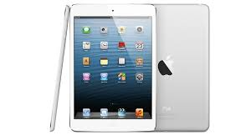

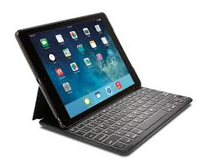

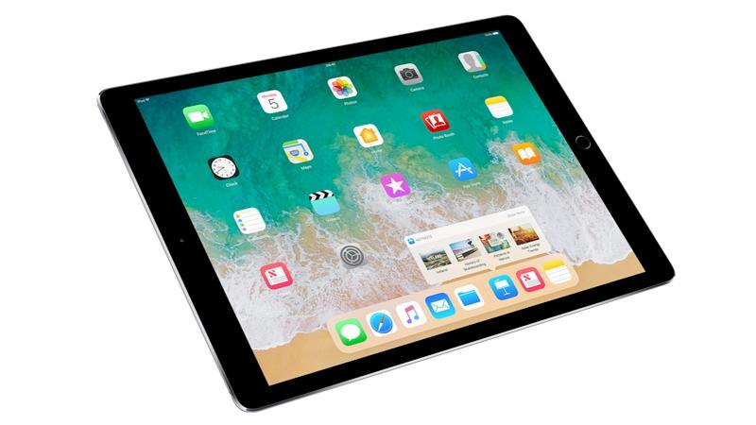

Dalyellup Primary School: Required Student Apps for 1:1 Program 2019

Paid Apps | Cost | Literacy & Numeracy Apps | Productivity, Utility & Coding Apps
Math Bingo | $4.49 | Prodigy Math Game | Stop Motion Studio | ABC iView | Garage Band | Adobe Photoshop Express | Thinglink | codeSpark Academy
King of Maths: Full Game | $4.49 | My Times Tables | 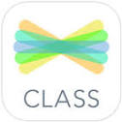  See Saw: The Learning Journal | iTunes U | 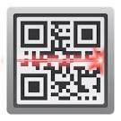  QR Code Reader | 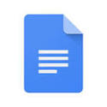  Google Docs | Tickle | Masterpiece for Osmo
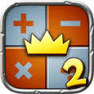  King of Maths 2: Full Game | $4.49 | 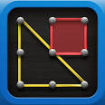  Geoboard | Showbie | NAP Locked Down Browser | Class Dojo | Google Drive | Edware | Newton for Osmo
Book Creator for iPad | $7.99 | 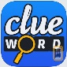  Clue Word | Keynote | KTdict C-E (Chinese-English Dictionary | Puppet Pals HD – free | Google Classroom | Tynker | Numbers for Osmo
Popplet | $7.99 | Word Seek HD Free | iMovie | Calculator for iPad Free | Explain Everything - Collaborate | 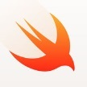  Swift Playgrounds | Kodable | 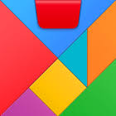  Tangram for Osmo
Lightbot: Programming Puzzles | $4.49 | 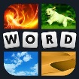  4 Pictures one Word | Edmodo | Fuji Xerox Print Utility | Flow Free | 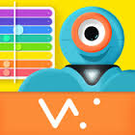  Xylo for Dash Robot | Lightbot: Code Hour | 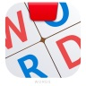  Osmo Words
Vocabulary Practice: Greek & Latin Root Words | $2.99 |  | Pic Collage | Pages | Apple Books | Ideament | Sphero | Adobe Spark Video

