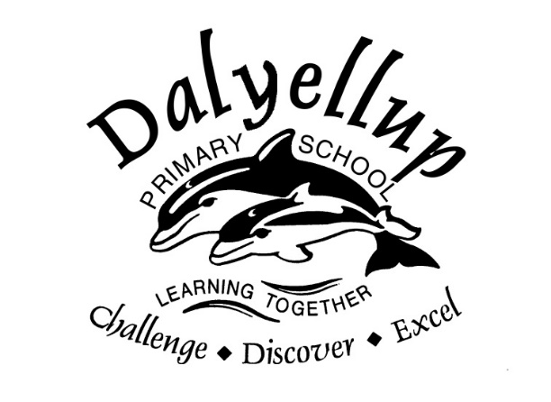

Dalyellup Primary School
2021 List of Required Apps for 1:1 iPad Program

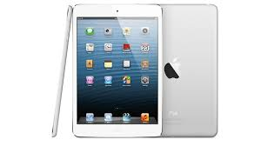

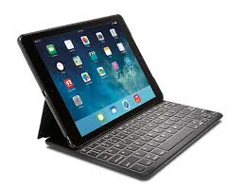

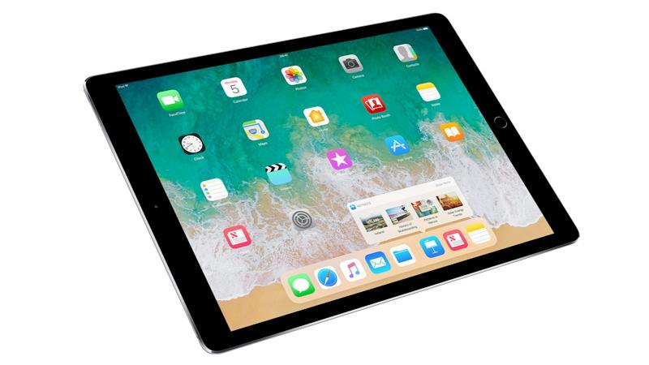

Dalyellup Primary School: Required Student Apps for 1:1 Program 2021
Paid Apps | Cost | Literacy & Numeracy Apps
Math Bingo | $4.49 | Prodigy Math Game | ABC iView | 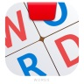  Osmo Words | codeSpark Academy | Thinglink | Microsoft 365  Suite
King of Maths: Full Game | $4.49 | Calculator for iPad Free | Stop Motion Studio | 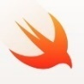  Swift Playgrounds | Masterpiece for Osmo | Tickle | Word
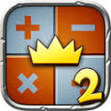  King of Maths 2: Full Game | $4.49 | 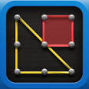  Geoboard | NAP Locked Down Browser | Adobe Photoshop Express | Newton for Osmo | Edware | Powerpoint
Book Creator for iPad | $7.99 | 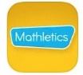  Mathletics Students | 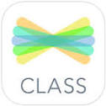  See Saw: The Learning Journal | Puppet Pals HD – free | Numbers for Osmo | Tynker | 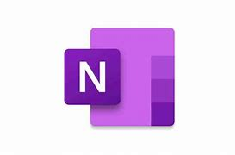  OneNote
Popplet | $7.99 | 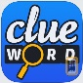  Clue Word | Edmodo | Explain Everything - Collaborate | Tangram for Osmo | Kodable | 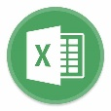  Excel
Lightbot: Programming Puzzles | $4.49 | Word Seek HD Free | Fuji Xerox Print Utility | Flow Free | 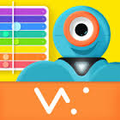  Xylo for Dash Robot | Lightbot: Code Hour | 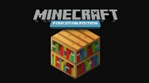  Minecraft Education
My Times Tables  (unlimited) | $4.99 |  | Pic Collage | Ideament | Sphero | Adobe Spark Video | Do not open these programs until school begins.

